Topic 11: Nuclear Radiation

1.1 Specification notice:
In order to develop their practical skills, students should be encouraged to carry out a range of practical experiments related to this topic. Possible experiments include measuring the half-life of a radioactive material.
Mathematical skills that could be developed in this topic include applying the concepts underlying calculus (but without requiring the explicit use of derivatives or integrals) by solving equations involving rates of change, for example. Δx /Δt = –λx using a graphical method or spreadsheet modelling and understanding probability in the context of radioactive decay.
This topic may be studied using applications that relate to nuclear radiation, for example nuclear power stations and medical physics.

11.Q Exam questions
How would you prove this curve is exponential?  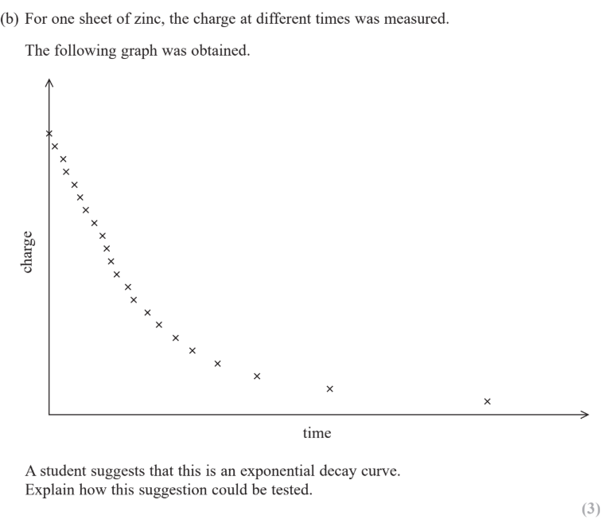 | 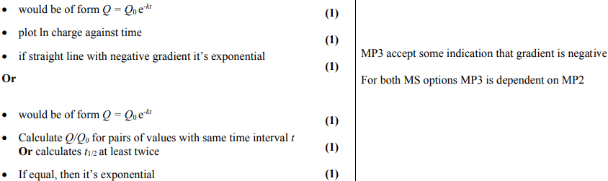  - Form Q=Q₀ e^{-kt}  - Plot ln charge against time  - If straight line with negative gradient its exponential  OR  - Form Q=Q₀e^{-kt}  - Calc Q/Q₀ for pairs of values with same time interval t OR calc t_{1/2} at least twice  - If equal then it’s exponential
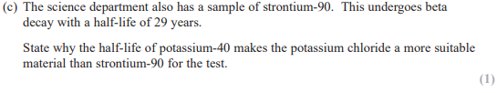  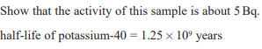  State why the half life of potassium-40 make the potassium chloride a more suitable material than strontium-90 for the test? | 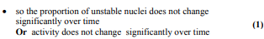
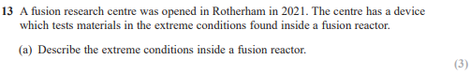  Describe the extreme conditions inside a fusion reactor? (3) | 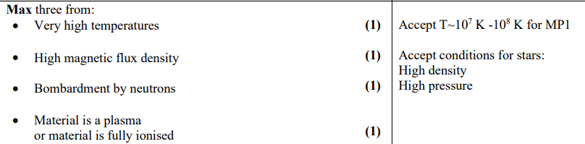  - Very high temperatures (1)  - Very high densities (1)  - High magnetic flux density (1)  - Bombardment by neutrons (1)  - Material is a plasma (or material is fully ionised) (1)

11.164 understand the concept of nuclear binding energy and be able to use the equation ΔE = c²Δm in calculations of nuclear mass (including mass deficit) and energy
Define binding energy (2)? | The energy equal to the mass defect (1) and when the nucleons bind together to form an atomic nucleus (1)  This could also be considered the energy needed to separate the nucleus into its individual separate nucleons
What is a mass defect? | The difference between the mass of the separate nucleons added together and when all the nucleons are together in the nucleus.  The latter is less since it is more stable when it is together. When a nucleus is formed, this mass is released as energy

11.165 use the atomic mass unit (u) to express small masses and convert between this and SI units

11.166 understand the processes of nuclear fusion and fission with reference to the binding energy per nucleon curve
Draw and describe the graph for ‘ Binding Energy per Nucleon’ v ‘Nucleon Number’ | 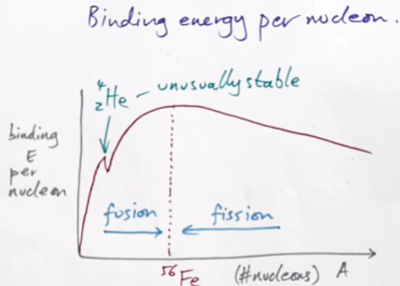  Remember that helium is unusually stable - hence why we get alpha particles during radioactive decay.  - The greater the binding energy per nucleon, the more stable a nucleus is (as show iron).  - We can get energy out by 2 ways as nuclei progress closer towards iron:  - Fusion occurs to the left of iron as lighter nuclei fuse into heavier nuclei  - Fissions occurs to the right of iron as heavy nuclei split into lighter nuclei.  This is shown below:  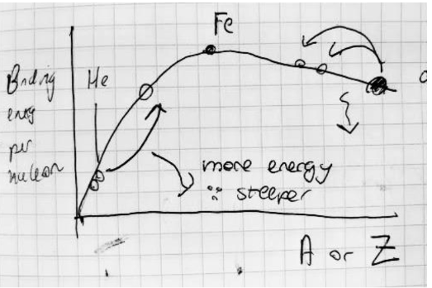  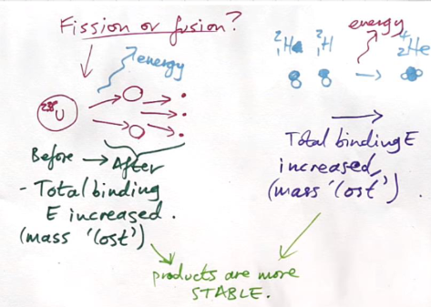  Where in both cases, energy is given out and products become more stable. It is less stable as you go further right as the strong nuclear force cannot hold all the neutrons together.  It gets more stable towards iron as a lot more energy is required to remove each nucleon from its nuclide. For this reason, its difficult to fuse heavy nuclei or fission light nuclei as more energy is required than you get out
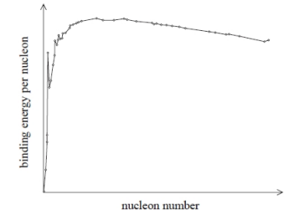  Use the binding energy per nucleon curve to explain how fusion and fission both release energy. (3) | - Fusion involves an increase in binding energy per nucleon as the number of nucleons increases (1)  - Fission involves an increase in binding energy per nucleon as the number of nucleons decreases (1)  - If binding energy per nucleon increases energy is released in the process (1)

11.167 understand the mechanism of nuclear fusion and the need for very high densities of matter and very high temperatures to bring about and maintain nuclear fusion
What are the conditions required for nuclear fusion and why? | - Very high temperature and so nuclei have high KE to overcome the large electrostatic repulsion between positively charged nuclei (1)  - Very high density to ensure nuclei are close enough together to fuse and to maintain high collision rate to maintain fusion (2)  Must say VERY HIGH  Some Mark Schemes allow pressure for density but just say high density as not all of them allow pressure

11.168 understand that there is background radiation and how to take appropriate account of it in calculations
Where does background radiation come from? (both natural and man-made) | - Natural:  - Cosmic rays.  - Natural radioactive material in rocks/soil  - Radon gas  - Food  - Man-made:  - Medical sources  - Nuclear power stations

11.169 understand the relationships between the nature, penetration, ionising ability and range in different materials of nuclear radiations (alpha, beta and gamma)
How does 𝜶, 𝛃 and γ radiation vary in penetration? | - Alpha particles are stopped by a few cm of air / thin sheet of paper.  - Beta particles are stopped by a few mm of aluminium  - Gamma ray intensity is halved by 10cm of lead  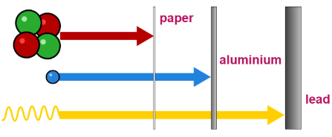

11.170 be able to write and interpret nuclear equations given the relevant particle symbols

11.171 CORE PRACTICAL 15: Investigate the absorption of gamma radiation by lead.
What MUST be measured before carrying out an experiment using radioactivity? | Measure BACKGROUND count rate over a course of 10 minutes then find the count rate for over 1 minute  You may have to change it into seconds/becquerels if the question requires it
How should you deal with anomalies during a radioactivity experiment?  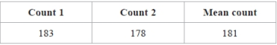 | Don’t ignore them, use them when calculating means.  Since radioactivity decay is a random process, you cannot predict when an individual nucleus will decay. Yet with a large number of nuclei, you can use a statistical approach
What are the 3 ways in determining the half life of a source? | - You can take logs of N,A or C and draw a graph of LogN against time where gradient would be -𝝺 then sub into N=N0e^{-𝝺t} to find t  - Interpolate a N,A or C against time graph for 3 pairs of half lives unless quoted otherwise to find t  - If your given the decay constant you could do ln2/𝝺 to find t

11.172 understand the spontaneous and random nature of nuclear decay
Define spontaneous decay? (1) | Decay that happens without any external stimulus (1)  (or decay that is unaffected by external factors such as temperature)  Do not allow references to the randomness of the decay
Define random decay? | A process in which the exact time of decay of a nucleus cannot be predicted

11.173 be able to determine the half-lives of radioactive isotopes graphically and be able to use the equations for radioactive decay: activity $A = λN, \frac{dN}{dt}=-λN,λ=\frac{ln2}{t_{\frac{1}{2}}}, N = N_{0} e^{-λt}$ and $A = A_{0}e^{-λt}$ derive and use the corresponding log equations. [Personal note include $C = {C_{0}e}^{-λt}$]
Define isotopes? (1) | Isotopes are atoms (nuclides) with the same number of protons but a different number of neutrons (nucleons) in the nucleus (1)
How would you derive Ln(A)=Ln(A₀) - 𝝺t from A = A₀e^{-𝝺t} | - A=A₀e^{-𝝺t}  - LnA = LnA₀ + lne^{-𝝺t}  - LnA = LnA₀ - 𝝺t
What is the activity of a sample defined as and was it it usually measure in? | The number of decays per second taking part in a source measured in becquerels (Bq).  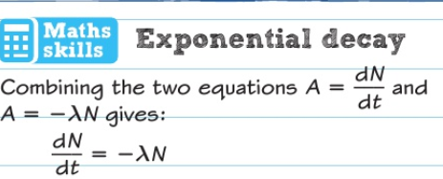  dN = change in number of undecayed nuclei  dt = change in time in seconds  Also known as the average number of disintegrations per second
What is the decay constant 𝝺 defined as? | The probability that a nucleus will decay in the next second (s⁻¹)  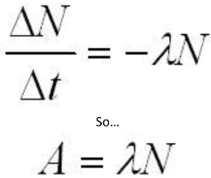  This makes sense if you think about it since multiplying the probability of decay per second by the number of nuclei will give you the number of decays per second.  And using differential equations of dN/dt = -𝝺N, you can derive:  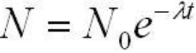
What are the 3 definitions of half life of a sample and the 3 equations | - The time it takes half the nuclei in a source to decay and N=N₀e^{-λt}  - The time it takes the count rate to half and C=C₀e^{-λt}  - The time it takes the activity to half and A=A₀e^{-λt}  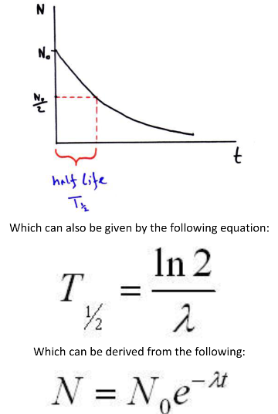
How does radioactive dating work? | Once a plant or animal dies, its carbon-14 content gradually decreasing and by comparing the amount found on the ancient artifact with the amount we would expect, we can date it.  We often assume the proportion of carbon-14 in the atmosphere has stayed constant which depends on whether the amount of cosmic rays penetrating the atmosphere was the same

